|  |  |  |  |  |  |
| --- | --- | --- | --- | --- | --- |
| ***Response to ALL student problem behavior is:***  ***Calm, consistent, brief, immediate, respectful, and private*** | | | | | |
|  |  | | | |  |
| **Teacher Managed** | **No** | **Is the behavior office managed?** | | **Yes** | **Administrator Managed** |
|  |  | |  | |  |
| **Intervention 1**   * Redirect/Reteach * Determine intervention * Document on Level I * Parent contact |  | |  | | **For a major offense:**  **The teacher enters a referral into Skyward for a major offense. Admin may enter the referral in certain instances.** |
| **Minor**  **Teacher Managed**   * Inappropriate language * Profanity * Inappropriate physical contact * Defiance * Disrespect * Non-compliance * Disruption * Talking while the teacher is talking * Property misuse * Dress code violation * Cheating * Electronic devices * Stealing * Unprepared for class | | **Major**  **Admin Managed**   * Fighting/Physical aggression * Bullying/Harassment * Repetitive Level 1 infractions * Verbally abusive * Severe defiance * Safety concern * Electronic devices severe * Drugs * Alcohol * Weapons | |
|  |  |
| **Intervention 2**   * Redirect/Reteach * Determine intervention * Document on Level I * Parent Contact | **Administrator will:**   * Review incident * State expected behavior * Determine consequences * Informs parent/guardian parents * Provides teacher feedback |
|  |
| **Intervention 3**   * Redirect/Reteach * Determine intervention * Document on Level I * Parent Contact * Discuss infraction with grade level PBIS member |
|  |
|  |  | |  | | **Clinic Managed** |
| **Intervention 4**   * Redirect/Reteach * Determine intervention * Document on Level I * Schedule Parent Teacher Conference | **Possible Interventions:**   * Apology note * Reflection sheet * Verbal warning * Loss of privilege * Time out/in class * Student conference * Restitution * Counseling * Detention (lunch, before/after school) | | **Resources:**   * APE PBIS Schoology * PBIS World * CHAMPS * Foundations * Classroom Management Checklist * Campus PBIS Facilitator Mrs. Savannah Ray | | **Nurse/Clinic Visits**  Ifa student is injured, has a fight, notifies you of an ailment, etc. always send the student to the clinic.  The clinic will:   * notify parents of the reason for visit. * If necessary, the clinic will advise parents admin is taking care of the incident. |
|  |
| **Intervention 5**   * Submit Skyward referral |
|  |
| **If Behavior Continues:**   * Referral for Tier 2 * SST/PBIS assistance |  | |  | |  |

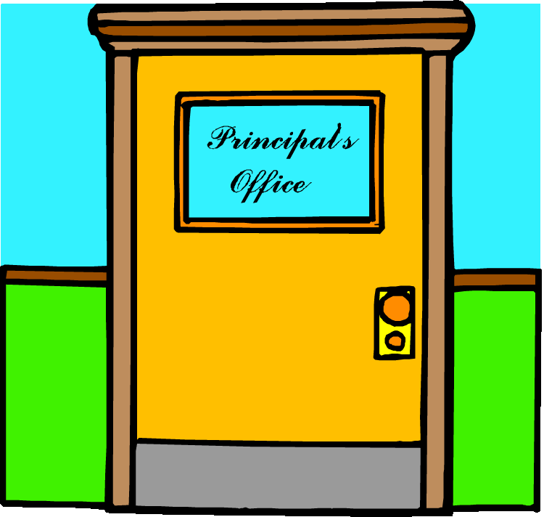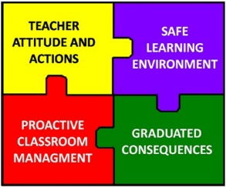

**Austin Parkway Elementary**

**Behavior Response Progression**